Final Project Design
You must submit this entire document along with the corresponding Alice file at each phase of the design. You will add to both the document and the Alice project at each step. By the last week of the semester, your project will be almost complete.
Save this file as Lastname_Firstname_FinalProject.docx
Do Not delete any part of this document or reformat it.
Step 1: Final Project Proposal
Your name: Janet Joy
Title of story: Jack and the Beanstalk
Link to the website where this story can be found. This must be a known story featuring people or other bipeds! (In Alice, Bipeds stand on two legs. In addition to people the Wolf, Pig, Rabbit and a few other characters are bipeds.) https://en.wikipedia.org/wiki/Jack_and_the_Beanstalk

A synopsis of the story you are going to tell. Write the synopsis as 5 or 6 sentences that give the major events of the story.
- Jack’s poor widowed mother tells him they are starving.
- Jack’s mother tells him to trade the cow for food to eat.
- Jack takes the cow to the market and trades it for magic beans.
- The beans grow into a beanstalk that reaches the castle of a giant.
- Jack climbs the beanstalk and steals a goose that lays golden eggs.
- The giant chases Jack, but Jack chops down the beanstalk.
- Jack and his mother grow rich and live happily ever after.
Your movie must have 3 different locations (Cottage, Forest, Town, Palace, etc.) List the locations here:
- Cottage porch
- Market
- Giant’ castle
Your movie will be interactive. Give an alternate ending that could result based on choices the user makes.
- Jack does not trade the cow for the beans.
- Jack does not chop down the beanstalk. The giant kills Jack and his mother.
What choice will the user make that will result in the second ending?
The user decides if Jack should trade the cow for beans, and whether to chop down the beanstalk.
Why did you pick this story?
Why did you pick this story?
My mother told me this story when I was little. She did a lot of sound effects, and used different voices for the characters. That made it fun to listen to.
Start a new Alice 3 project, if you are going to have a room in your story, be sure to select the room to start. Save the project as Lastname_Firstname_FinalProject1.a3p
Add comments to my first method with your name, title of the story, and the synopsis.
In setup scene view, add all the characters and animals that will be in the movie.
Submit this document with step one completed (nothing deleted) and the Lastname_Firstname_FinalProject1.a3p file in assignments.
Step 2: Storyboard and Sound
Using the synopsis of the story, create a storyboard showing each of the major steps that will occur. Your storyboard must have at least 10 frames with a unique title, the major events, characters, location changes, and dialog. The storyboard is your own work. You can draw stick figures on paper, then take a picture or use any drawing software. You may NOT use artwork done by anyone else. Paste the storyboard here:
Frame 1: Starving  Location: cottage  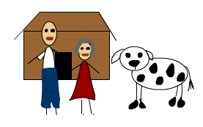  Mother: Jack, we have nothing to eat.  Jack: I know, mom, what are we going to do?  Mother: Take the cow and sell it for as much food as you can.  Jack: OK. | 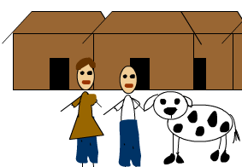  Frame 2: Sell Cow  Location: Market  Jack: I need to sell this cow. What will you give me for it?  Tradesman: I will give you these magic beans.  Jack: Great!
Frame 3: Beans  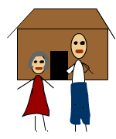  Location cottage  Jack: Look Mom, I got some magic beans!  Mother: You fool! How could you trade our cow for a handful of worthless beans?  Mother throws beans away. | 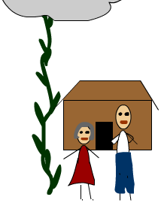  Frame 4: Beanstalk  Location: cottage with beanstalk  Jack: Look Mom, the beans grew into a magic beanstalk!  Mother: Amazing! It goes up to the clouds!  Jack: I’m going to climb it.
  Frame 5: Climbing the beanstalk  Location: above cottage  Jack climbs the beanstalk | 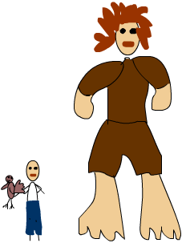  Frame 6: A Giant  Location: Giants castle  Jack finds himself in the castle of an unfriendly giant who is sleeping.  Jack: Look, it's the goose that lays golden eggs!  Jack grabs goose.  Goose: Help! Help! Squawk, squawk.  The giant wakes up and chases jack  Giant: Fe-fi-fo-fum! I smell the blood of an Englishman!  Jack thinks: Uh-oh!
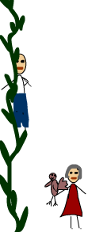  Frame 7: The Chase  Location: above cottage  Jack goes down beanstalk with the giant chasing him.  Jack throws the goose to his mother  Jack: Mom! Catch! It’s the goose that lays golden eggs  Mom: Jack, hurry! | Frame 8: Chop down beanstalk  Location: cottage  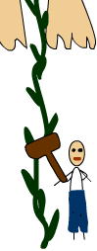  Jack: What should I use to chop down the beanstalk?  User will click the hammer,  Jack grabs the hammer and chops down beanstalk.
Frame 9: The giant falls  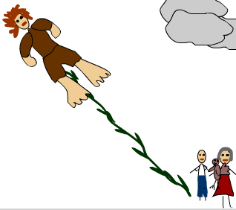  Location: cottage  Jack chops down the beanstalk and the giant falls. | Scene 10: Riches  Location: cottage  Jack and mother grow rich from the goose that lays golden eggs  Mother: We are rich now.  Mother: I’m sorry I called you an idiot.  Jack: That’s Ok Mom.  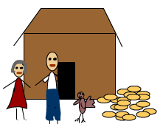

What is the title of each frame:
- Starving
- Sell cow
- Beans
- Beanstalk
- Climbing the beanstalk
- A giant
- The chase
- Chop down beanstalk
- Giant falls
- Riches
Open the final project, lastname_firstname_finalproject1.a3p, and save it as lastname_firstname_finalproject2.a3p. For each frame in the storyboard add a separate comment to myFirstMethod to show the title, location and brief description.
If there are items in your story that are not in Alice, how have you represented them?
Billboards can display a picture, or you can substitute something.
I use a billboard for the marketplace. There is no goose, I am using a sea gull. I am using bamboo for the beanstalk. There is no axe, so I am using the Mjolnir (the hammer of Thor).
From the menu select Project, Resource manager, import audio. Import at least 3 sounds that you will use in the final project. List those 3 sounds here: chopping sound, cow mooing, goose honking,
Submit this document with all previous steps completed (nothing deleted) and the Lastname_Firstname_FinalProject2.a3p file in assignments.
Step 3: Final Project Locations
Open the final project, lastname_firstname_finalproject2.a3p, and save it as lastname_firstname_finalproject3.a3p.
Create your 3 locations with one location on the left, one in the middle and one on the right. Add all the characters and objects to the stage. (You can move them around with code later.) Create a camera marker for each location.
List those 3 locations here. Cottage, marketplace, giants castle
Step 4: Scene Procedures
Open the final project, lastname_firstname_finalproject3.a3p, and save it as lastname_firstname_finalproject4.a3p.
For each of the lines of the algorithm create a Scene Procedure. Add comments to each scene procedure to tell what happens in that scene. List the location, actors, and props that you will use in each scene. For now, just include the main story, not the alternate ending.
- Add the code to move the camera marker to the location for the scene.
- Add all the dialog from the storyboard to the correct Scene Procedure.
- Add the code to play the sound in the scene procedure where it belongs.
- Add comments to tell what actions will take place: walk, bow, climb, etc.
Do not add the code to MyFirstMethod.
Add calls to the procedures to MyFirstMethod.
Scenes: _________, _________, _________, _________, _________, _________,
Actions: _________, _________, _________, _________, _________, _________,
Submit this document with steps one and two completed (nothing deleted) and the Lastname_Firstname_FinalProject4.a3p file in assignments.
Step 5: Final Project Interactions:
Tell how you will make the story interactive? List at least two questions the actors ask of the user. The answer must change the movie in some way. Example: How many times should I knock? Should I go left or right? Etc. Should I pick some flowers? If the user answers yes, call a separate scene procedure to pick the flowers.

In Alice, you can select an object by clicking on it. List one choice the user can make by clicking on the choice. Example: Click on the tool that will open the lock. Click on each pig to make him run away. Click on the gate to open it.

Open the final project, lastname_firstname_finalproject4.a3p, and save it as lastname_firstname_finalproject5.a3p. Add the variables and the questions to store the results in the variables to the Scene Procedure where the question will be asked. (You will add the response to the questions and the clicking part later.) Do NOT add any code to MyFirstMethod. Any new code should be in one of the scene procedures.
Which scene procedures have you added code to? _________, _________, _________, _________,
Submit this document with all previous steps completed (nothing deleted) and the Lastname_Firstname_FinalProject5.a3p file in assignments.
Step 6: Biped Procedures
Open the final project, lastname_firstname_finalproject5.a3p, and save it as lastname_firstname_finalproject6.a3p. From the actions you listed in step 4, create at least 3 biped procedures. For each procedure add comments to tell what occurs. Add calls for each procedure at the appropriate places, replacing the code that you wrote previously.
The procedures will work for all instances of the class, so add parameters to the procedures so that some can walk faster or slower, etc. Add calls to these procedures to scene procedures, not MyFirstMethod.
You may have the same actions in more than one scene. For instance, walking may occur for multiple characters, in multiple scenes.
What biped procedures have you added: _________, _________, _________,
Which scene procedures call these biped procedures? _________, _________, _________,
Submit this document with all previous steps completed (nothing deleted) and the Lastname_Firstname_FinalProject6.a3p file in assignments.
Step 7: Arrays
Open the final project, lastname_firstname_finalproject6.a3p, and save it as lastname_firstname_finalproject7.a3p. Find someplace where several objects do the same thing. Modify the code to use an array. For instance, you may want to make several items invisible by setting the opacity to 0. Create an array of these things, then use a loop to change the opacity.
Do NOT add any code to MyFirstMethod. Any new code should be in one of the scene procedures.
What array have you added: _________ Which scene procedure uses the array? _______
Submit this document with all previous steps completed (nothing deleted) and the Lastname_Firstname_FinalProject7.a3p file in assignments.
Step 8: Events and Alternate Ending
Open the final project, lastname_firstname_finalproject7.a3p, and save it as lastname_firstname_finalproject8.a3p. Find someplace where you can interact with the user by having them click on a choice. Add the click event to the code. Add another event.
You may need to modify MyFirstMethod and add a scene procedure(s) for the alternate ending at this point.
What events have you added: _________, _________, _________,
Submit this document with steps one to 8 completed (nothing deleted) and the Lastname_Firstname_FinalProject8.a3p file in assignments.
Finish
Continue to add the finishing touches to the final project. Be sure to add comments, and save often using a progression of numbers as you have done throughout the design process.

